Lab Taks-3

Submission Guidelines-
- Rename the file to your id only. If your id is 18-XXXXX-1, then the file name must be 18-XXXXX-1.docx.
- Must submit within time that will be discussed in class VUES to the section named Lab Tak-3
- Must include resources for all the section in the table
Question- 1

Draw five storied building with windows and a front door

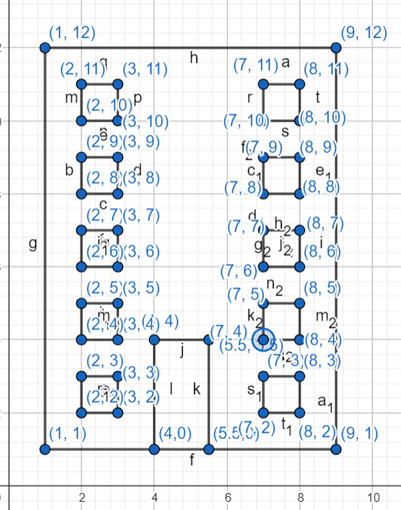
Graph Plot (Picture)-

Code-

#include <windows.h> // for MS Windows
#include <GL/glut.h> // GLUT, include glu.h and gl.h

/* Initialize OpenGL Graphics */
void initGL() {
// Set "clearing" or background color
glClearColor(1.0f, 1.0f, 1.0f, 1.0f); // Black and opaque
}

/* Handler for window-repaint event. Call back when the window first appears and
whenever the window needs to be re-painted. */
void display() {
glClear(GL_COLOR_BUFFER_BIT); // Clear the color buffer with current clearing color

glBegin(GL_QUADS); // These vertices form a closed polygon
glColor3f(0,153,0); // Yellow
glVertex2f(1.0f, 1.0f);
glVertex2f(9.0f, 1.0f);
glVertex2f(9.0f, 12.0f);
glVertex2f(1.0f, 12.0f);
glEnd();

glBegin(GL_QUADS); // These vertices form a closed polygon
glColor3f(255,255,255); // Yellow
glVertex2f(4.0f, 0.0f);
glVertex2f(5.50f, 0.0f);
glVertex2f(5.50f, 3.50f);
glVertex2f(4.0f, 3.50f);
glEnd();

glBegin(GL_QUADS); // These vertices form a closed polygon
glColor3f(255,255,255); // Yellow
glVertex2f(7.0f, 2.0f);
glVertex2f(8.0f, 2.0f);
glVertex2f(8.0f, 3.0f);
glVertex2f(7.0f, 3.0f);
glEnd();

glBegin(GL_QUADS); // These vertices form a closed polygon
glColor3f(255,255,255); // Yellow
glVertex2f(7.0f, 4.0f);
glVertex2f(8.0f, 4.0f);
glVertex2f(8.0f, 5.0f);
glVertex2f(7.0f, 5.0f);
glEnd();

glBegin(GL_QUADS); // These vertices form a closed polygon
glColor3f(255,255,255); // Yellow
glVertex2f(7.0f, 6.0f);
glVertex2f(8.0f, 6.0f);
glVertex2f(8.0f, 7.0f);
glVertex2f(7.0f, 7.0f);
glEnd();

glBegin(GL_QUADS); // These vertices form a closed polygon
glColor3f(255,255,255); // Yellow
glVertex2f(7.0f, 8.0f);
glVertex2f(8.0f, 8.0f);
glVertex2f(8.0f, 9.0f);
glVertex2f(7.0f, 9.0f);
glEnd();

glBegin(GL_QUADS); // These vertices form a closed polygon
glColor3f(255,255,255); // Yellow
glVertex2f(7.0f, 10.0f);
glVertex2f(8.0f, 10.0f);
glVertex2f(8.0f, 11.0f);
glVertex2f(7.0f, 11.0f);
glEnd();

glBegin(GL_QUADS); // These vertices form a closed polygon
glColor3f(255,255,255); // Yellow
glVertex2f(2.0f, 11.0f);
glVertex2f(3.0f, 11.0f);
glVertex2f(3.0f, 10.0f);
glVertex2f(2.0f, 10.0f);
glEnd();

glBegin(GL_QUADS); // These vertices form a closed polygon
glColor3f(255,255,255); // Yellow
glVertex2f(2.0f, 9.0f);
glVertex2f(3.0f, 9.0f);
glVertex2f(3.0f, 8.0f);
glVertex2f(2.0f, 8.0f);
glEnd();

glBegin(GL_QUADS); // These vertices form a closed polygon
glColor3f(255,255,255); // Yellow
glVertex2f(2.0f, 7.0f);
glVertex2f(3.0f, 7.0f);
glVertex2f(3.0f, 6.0f);
glVertex2f(2.0f, 6.0f);
glEnd();

glBegin(GL_QUADS); // These vertices form a closed polygon
glColor3f(255,255,255); // Yellow
glVertex2f(2.0f, 5.0f);
glVertex2f(3.0f, 5.0f);
glVertex2f(3.0f, 4.0f);
glVertex2f(2.0f, 4.0f);
glEnd();

glBegin(GL_QUADS); // These vertices form a closed polygon
glColor3f(255,255,255); // Yellow
glVertex2f(2.0f, 3.0f);
glVertex2f(3.0f, 3.0f);
glVertex2f(3.0f, 2.0f);
glVertex2f(2.0f, 2.0f);
glEnd();

glFlush(); // Render now
}

/* Main function: GLUT runs as a console application starting at main() */
int main(int argc, char** argv) {
glutInit(&argc, argv); // Initialize GLUT
glutCreateWindow("Building"); // Create window with the given title
glutInitWindowSize(320, 320); // Set the window's initial width & height
glutInitWindowPosition(50, 50); // Position the window's initial top-left corner
glutDisplayFunc(display);
gluOrtho2D(-15,15,-15,15); // Register callback handler for window re-paint event
initGL(); // Our own OpenGL initialization
glutMainLoop(); // Enter the event-processing loop
return 0;
}

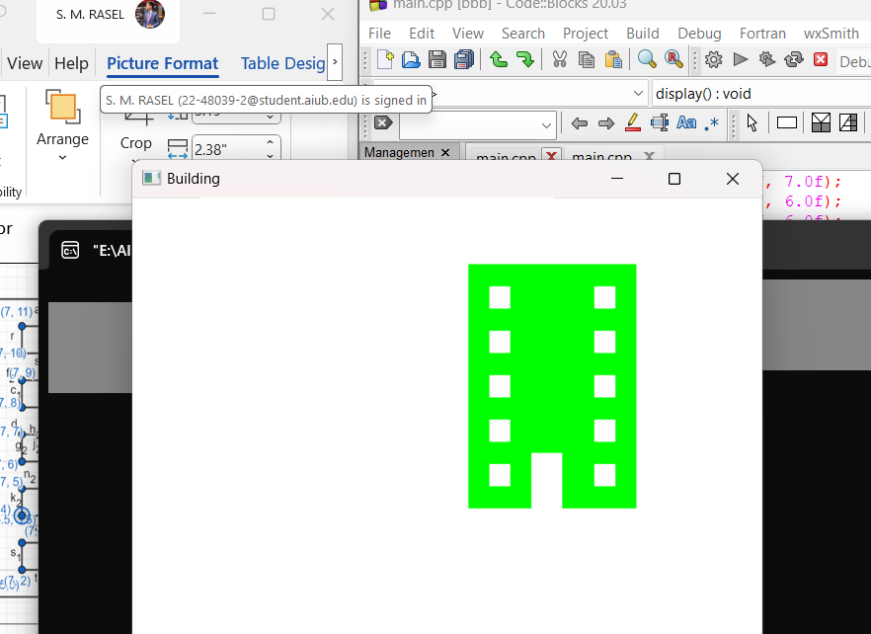
Output Screenshot (Full Screen)-

Question- 2

Draw a tree

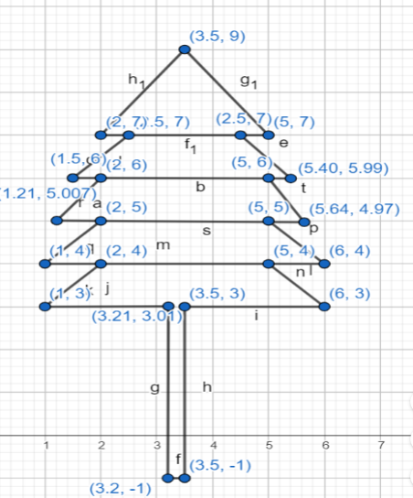
Graph Plot (Picture)-

Code-
#include <windows.h> // for MS Windows
#include <GL/glut.h> // GLUT, include glu.h and gl.h
void code()
{
glPointSize(5.0);
glBegin(GL_POLYGON);
glColor3f(0.3529f, 0.2235f, 0.0902f);

glBegin(GL_POLYGON);

glVertex2f(3.2f, -1.0f);
glVertex2f(3.5f, -1.0f);
glVertex2f(3.5f, 3.0f);
glVertex2f(3.210f, 3.0f);
glEnd();

glColor3f(0.0f, 0.50f, 0.0f); //Green
glBegin(GL_POLYGON);

glVertex2f(3.5f, 9.0f);
glVertex2f(5.0f, 7.0f);
glVertex2f(2.5f,7.0f);
glVertex2f(5.40f,5.99f);
glVertex2f(5.0f,6.0f);///
glVertex2f(5.64f,4.97f);
glVertex2f(5.0f,5.0f);///
glVertex2f(6.0f,4.0f);
glVertex2f(5.0f,4.0f);
glVertex2f(6.0f,3.0f);
glVertex2f(3.5f,3.0f);
glVertex2f(3.21f,3.01f);
glVertex2f(1.0f,3.0f);
glVertex2f(2.0f,4.0f);
glVertex2f(1.0f,4.0f);
glVertex2f(2.0f,5.0f);
glVertex2f(1.210f,5.007f);
glVertex2f(2.0f,6.0f);
glVertex2f(1.50f,6.0f);
glVertex2f(5.0f,7.0f);
glVertex2f(2.0f,7.0f);

}

void display()
{
glClearColor(1.0f, 1.0f, 1.0f, 0.0f);
glClear(GL_COLOR_BUFFER_BIT);

code();
glEnd();

glFlush();
}

int main(int argc, char** argv)
{
glutInit(&argc, argv);
glutInitWindowSize(500,500);
glutInitWindowPosition(10,10);
glutCreateWindow("Tree");

glutDisplayFunc(display);
gluOrtho2D(-10,20,-5,10);
glutMainLoop();
return 0;
}


Output Screenshot (Full Screen)-

Question- 3

Draw a lamppost with black background

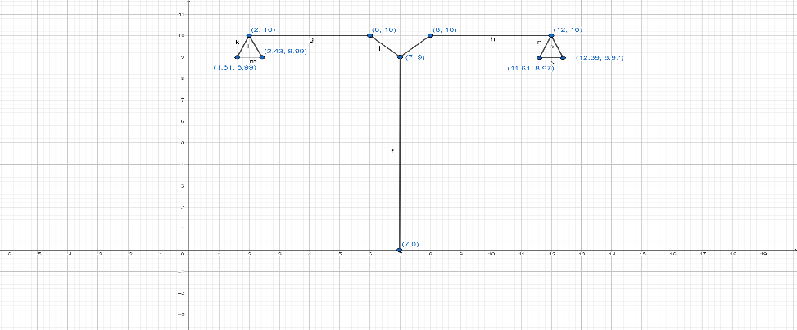
Graph Plot (Picture)-

Code-

#include <windows.h> // for MS Windows

#include <GL/glut.h> // GLUT, include glu.h and gl.h

/* Initialize OpenGL Graphics */

void initGL() {

glClearColor(0.0f, 0.0f, 0.0f, 1.0f); // Black and opaque

}

void display() {

glClear(GL_COLOR_BUFFER_BIT);

glBegin(GL_POLYGON);
glColor3ub(255,255,255);
glVertex2f(11.61f, 8.97f);
glVertex2f(12.39f, 8.97f);
glVertex2f(12.0f, 10.0f);

glEnd();

glLineWidth(1.5);

// Draw a Red 1x1 Square centered at origin

glBegin(GL_LINES); // Each set of 4 vertices form a quad

glColor3ub(153,76,0); // Red

glVertex2f(12.0f, 10.0f); // x, y

glVertex2f(8.0f, 10.0f); // x, y

glEnd();

glBegin(GL_LINES); // Each set of 4 vertices form a quad

glColor3ub(153,76,0); // Red

glVertex2f(8.0f, 10.0f); // x, y

glVertex2f(7.0f, 9.0f); // x, y

glEnd();

glBegin(GL_LINES); // Each set of 4 vertices form a quad

glColor3ub(153,76,0);// Red

glVertex2f(7.0f, 9.0f); // x, y

glVertex2f(6.0f, 10.0f); // x, y

glEnd();

glBegin(GL_LINES); // Each set of 4 vertices form a quad

glColor3ub(153,76,0); // Red

glVertex2f(6.0f, 10.0f); // x, y

glVertex2f(2.0f, 10.0f); // x, y

glEnd();

glBegin(GL_POLYGON); // These vertices form a closed polygon

glColor3ub(255,255,255); // Yellow

// Replace the vertices with the given coordinates
glVertex2f(2.0f, 10.0f);
glVertex2f(1.61f, 8.99f);
glVertex2f(2.43f, 8.99f);

glEnd();

glBegin(GL_LINES); // Each set of 4 vertices form a quad

glColor3ub(153,76,0); // Red

glVertex2f(7.0f, 9.0f); // x, y

glVertex2f(7.0f, 0.0f); // x, y

glEnd();

glFlush(); // Render now

}

/* Main function: GLUT runs as a console application starting at main() */

int main(int argc, char** argv) {

glutInit(&argc, argv); // Initialize GLUT

glutCreateWindow("Lampost");

glutInitWindowSize(320, 320);
glutInitWindowPosition(50, 50); // Position the window's initial top-left corner

glutDisplayFunc(display); // Register callback handler for window re-paint event

gluOrtho2D(-15,15,-15,15);

initGL(); // Our own OpenGL initialization

glutMainLoop(); // Enter the event-processing loop

return 0;

}

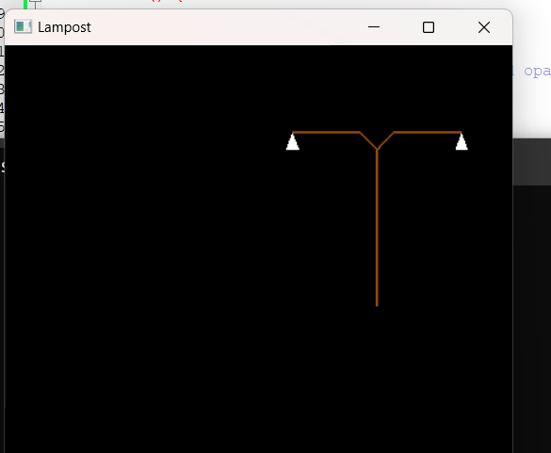
Output Screenshot (Full Screen)-

Question- 4

Draw a bench

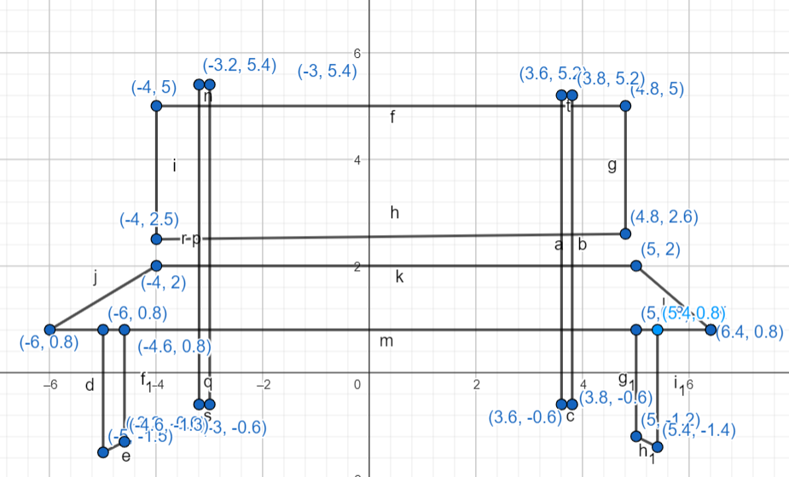
Graph Plot (Picture)-

Code-
#include <windows.h> // for MS Windows
#include <GL/glut.h> // GLUT, include glu.h and gl.h

/* Initialize OpenGL Graphics */
void initGL() {
// Set "clearing" or background color
glClearColor(0.0f, 0.0f, 0.0f, 1.0f); // Black and opaque
}

/* Handler for window-repaint event. Call back when the window first appears and
whenever the window needs to be re-painted. */
void display() {
glClear(GL_COLOR_BUFFER_BIT); // Clear the color buffer with current clearing color

glBegin(GL_QUADS); // These vertices form a closed polygon
glColor3f(255,255,255); // Yellow
glVertex2f(-5.0f, -1.5f);
glVertex2f(-4.6f, -1.3f);
glVertex2f(-4.6f, 0.8f);
glVertex2f(-5.0f, 0.8f);
glEnd();

glBegin(GL_QUADS); // These vertices form a closed polygon
glColor3f(255,255,255); // Yellow
glVertex2f(-3.2f, -0.6f);
glVertex2f(-3.0f, -0.6f);
glVertex2f(-3.0f, 5.4f);
glVertex2f(-3.2f, 5.4f);

glEnd();

glBegin(GL_QUADS); // These vertices form a closed polygon
glColor3f(255,255,255); // Yellow
glVertex2f(3.6f, -0.6f);
glVertex2f(3.8f, -0.6f);
glVertex2f(3.8f, 5.2f);
glVertex2f(3.6f, 5.2f);
glEnd();

glBegin(GL_QUADS); // These vertices form a closed polygon
glColor3ub(255,255,255); // Yellow
glVertex2f(5.0f, -1.2f);
glVertex2f(5.4f, -1.4f);
glVertex2f(5.4f, 0.8f);
glVertex2f(5.0f, 0.8f);
glEnd();

glBegin(GL_QUADS);
glColor3ub(153,0,0);
glVertex2f(-6.0f, 0.8f);
glVertex2f(6.4f, 0.8f);
glVertex2f(5.0f, 2.0f);
glVertex2f(-4.0f, 2.0f);

glEnd();

glBegin(GL_QUADS);
glColor3ub(128,255,0);
glVertex2f(-4.0f, 2.5f);
glVertex2f(4.8f, 2.6f);
glVertex2f(4.8f, 5.0f);
glVertex2f(-4.0f, 5.0f);

glEnd();

glFlush(); // Render now
}

/* Main function: GLUT runs as a console application starting at main() */
int main(int argc, char** argv) {
glutInit(&argc, argv); // Initialize GLUT
glutCreateWindow("Brench"); // Create window with the given title
glutInitWindowSize(320, 320); // Set the window's initial width & height
glutInitWindowPosition(50, 50); // Position the window's initial top-left corner
glutDisplayFunc(display);
gluOrtho2D(-15,15,-15,15); // Register callback handler for window re-paint event
initGL(); // Our own OpenGL initialization
glutMainLoop(); // Enter the event-processing loop
return 0;
}

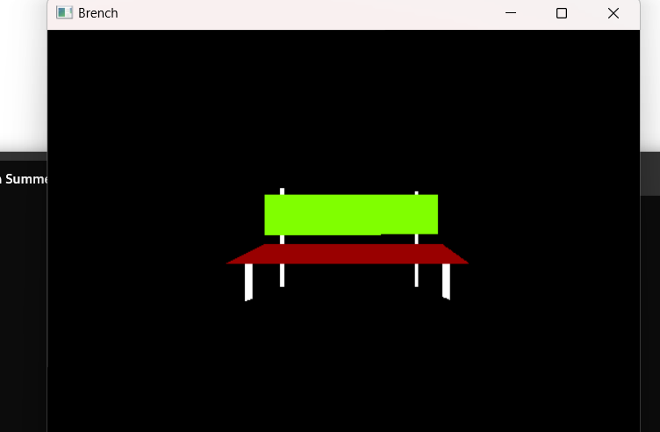
Output Screenshot (Full Screen)-

Question- 5

Use the building, tree, lamppost and bench to create a scenario

Graph Plot (Picture)-

Code-

Output Screenshot (Full Screen)-

